1.a)
i.
Y = (AB + CD)
ii.
A = 1 / A’ = 2
B = 1 / B’ = 2
C = 1 / C’ = 2
D = 1 / D’ = 2
iii.
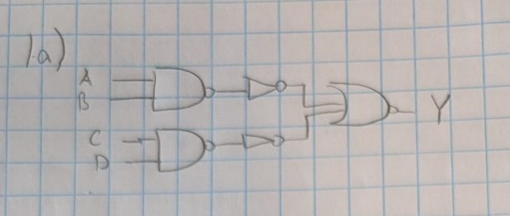
1.b)
i.
Y = (B + CD)
ii.
B = 2 / B’ = 2
C = 1 / C’ = 2
D = 1 / D’ = 2
iii.
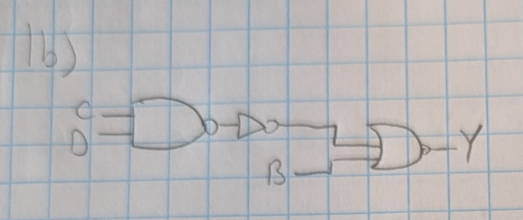
1.c)
i.
Y = (DE + AB + AC)
ii.
A = 1 / A’ = 2
B = 1 / B’ = 1
C = 1 / C’ = 1
D = 1 / D’ = 2
E = 1 / E’ = 2
iii.
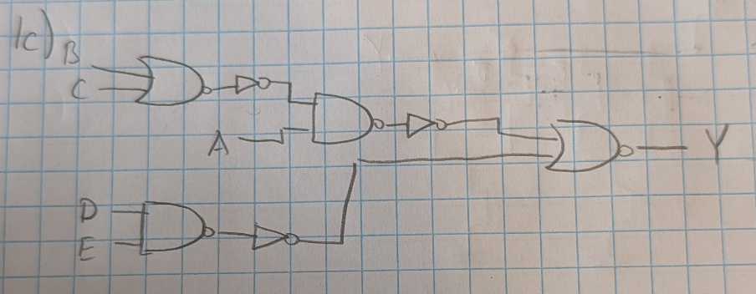

2.a)
Y = A(B+C+D)(C+BD’)
2.b+c)
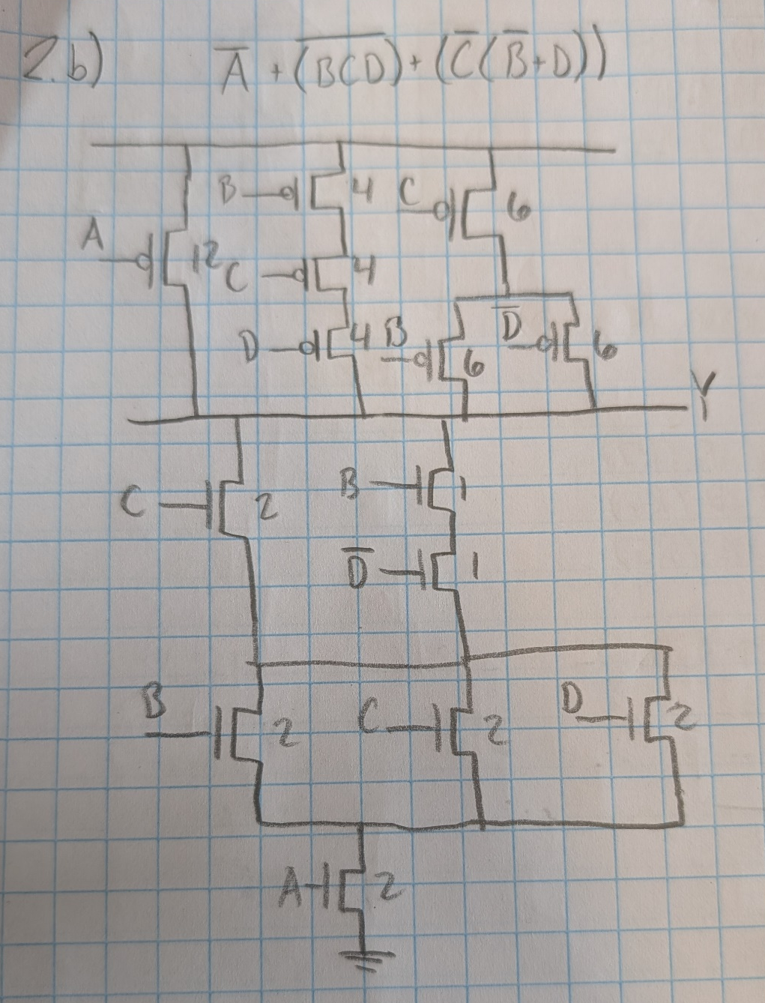
The sizes for part C are also in there

3.

